Idea:
Improve GUI Version for Scale 5.2.2.1.0
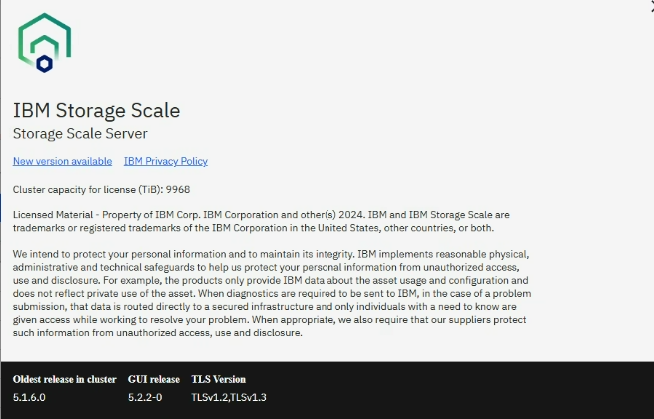

Different information about used capacity and total capacity.

Monitoring -> Files -> Filesets -> view details -> used capacity

Due to the fact, that two copies are made on the filesystem on ESS storage cluster netto and brutto capacity are different by factor 2
Customer does not understand why the numbers in a single view of the GUI have different meanings in matter of ‘netto’ and ‘brutto’ capacities. – no information, what is meant.
Used Capacity shows the physical used capacity 1.19 PiB (two times netto capacity 625 TiB) FileSystem total shows only the NETTO capacity : 4.87 PIB – half of the physical capacity 9.9 PiB)
