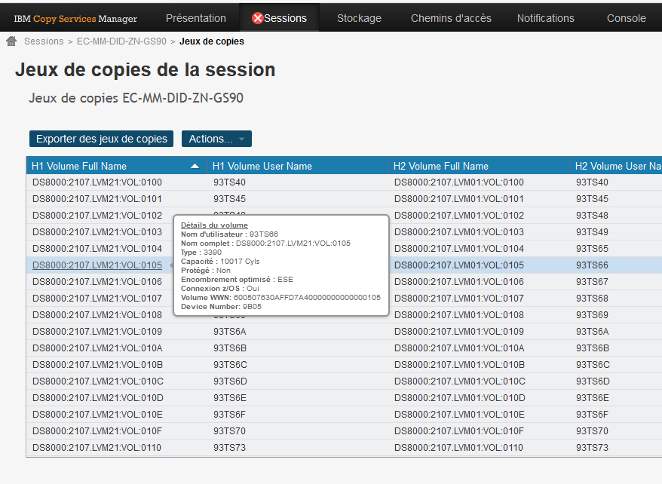
This above give a full accurate view of volumes and will help avoid finger check when dealing with more than 100000 on each CSM configuration.
Is there any way to toggle other view to have also “Hx Volume Full Name” display? (This s2 views for example):

