**Retrieve with GUI not possible**

Folder Structure is displayed but not the files!!

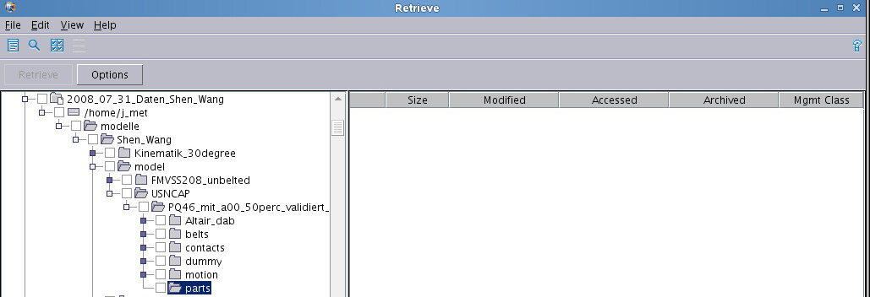

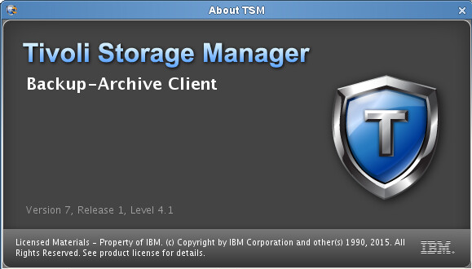

With commandline the files can be retrieved

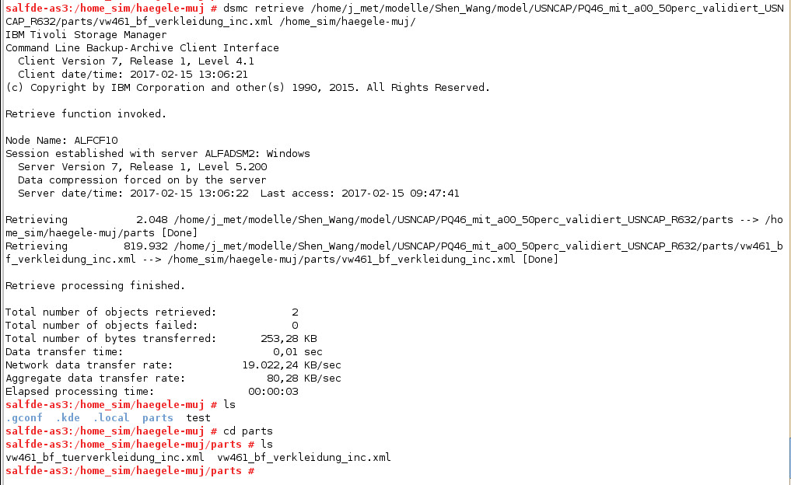

TSM server version

